**Week 2**

**Aim:** Convert the student’s record file into csv and import that file in R and create the frequency table and frequency polygon.

**Code:**

marksheet=read.csv("G:\\VIT\\Win Sem 2016\\Labs\\R Lab (MAT 2001)\\Week 3\\Week3.csv")

marks1=marksheet$Marks

int=seq(0,100,by=10)

int

frtable=cut(marks1,int)

table(frtable)

transform(table(frtable))

temp=hist(marks1,breaks=int,col="green",main="class marks distribution",xlab="Marks",ylab="No of students")

lines(c(min(temp$breaks),temp$mids,max(temp$breaks)),lwd=2,c(0,temp$counts,0),type="l")

summary(marks1)

var(marks1)

sd(marks1)

moment(marks1,order=2,central = TRUE)

skewness(marks1)

kurtosis(marks1)

**Input/Database use**

|  |
| --- |
| Marks |
| 54 |
| 54 |
| 57 |
| 56 |
| 86 |
| 84 |
| 83 |
| 95 |
| 72 |
| 65 |
| 84 |
| 95 |
| 75 |
| 52 |
| 87 |
| 35 |
| 75 |
| 84 |
| 92 |
| 72 |
| 1 |
| 20 |
| 100 |
| 81 |
| 73 |
| 94 |
| 76 |
| 81 |
| 53 |
| 94 |
| 53 |
| 78 |
| 35 |
| 29 |
| 78 |
| 95 |
| 45 |
| 53 |
| 84 |
| 4 |
| 45 |
| 45 |
| 54 |
| 51 |
| 29 |
| 78 |
| 35 |
| 78 |
| 84 |
| 95 |

Output:

> marksheet=read.csv("G:\\VIT\\Win Sem 2016\\Labs\\R Lab (MAT 2001)\\Week 3\\Week3.csv")

> marks1=marksheet$Marks

> int=seq(0,100,by=10)

> int

[1] 0 10 20 30 40 50 60 70 80 90 100

> frtable=cut(marks1,int)

> table(frtable)

frtable

(0,10] (10,20] (20,30] (30,40] (40,50] (50,60] (60,70] (70,80] (80,90]

2 1 2 3 3 10 1 10 10

(90,100]

8

> transform(table(frtable))

frtable Freq

1 (0,10] 2

2 (10,20] 1

3 (20,30] 2

4 (30,40] 3

5 (40,50] 3

6 (50,60] 10

7 (60,70] 1

8 (70,80] 10

9 (80,90] 10

10 (90,100] 8

> temp=hist(marks1,breaks=int,col="green",main="class marks distribution",xlab="Marks",ylab="No of students")

> lines(c(min(temp$breaks),temp$mids,max(temp$breaks)),lwd=2,c(0,temp$counts,0),type="l")

> summary(marks1)

Min. 1st Qu. Median Mean 3rd Qu. Max.

1.00 52.25 74.00 65.56 84.00 100.00

> var(marks1)

[1] 603.7616

> sd(marks1)

[1] 24.57156

> moment(marks1,order=2,central = TRUE)

[1] 591.6864

> skewness(marks1)

[1] -0.7316981

attr(,"method")

[1] "moment"

> kurtosis(marks1)

[1] -0.2294279

**Graph:**

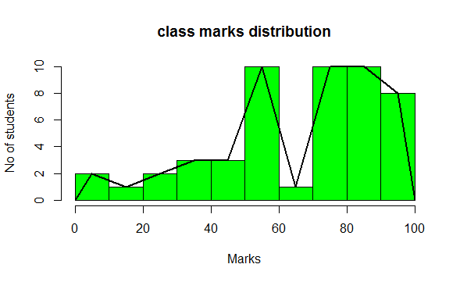

**Result/Inference**

The marks datasheet was implemented as a frequency table and a frequency polygon and the moments, skewness and kurtosis was also calculated.